**Porfolio Design Plan**

Student Number: [Your Student Number]

Module Name: Introduction to Programming

Submission Deadline:

**Table of Content**

**1. Introduction 2**

**1.1 Project Objectives 3**

**2. Site Map 3**

**3. Page Designs 3**

**3.1 Home Page 3**

**3.2 About Page 8**

**3.3 Projects Page 11**

**3.4 Skills Page 15**

**3.5 Achievements Page 19**

**3.6 Contact Page 23**

**4. Technical Specifications 26**

**4.1 Color Palette 26**

**4.2 Typography 26**

**4.3 Responsive Breakpoints 26**

**5. Interactive Elements 27**

**5.1 Navigation 27**

**5.2 Project Features 27**

**5.3 Forms 27**

**6. Alternative Design 27**

**6.1 Reason for Alternative Design 31**

**6.2 Justification 31**

**7. Testing Plan 32**

**7.1 Browser Testing 32**

**7.2 Device Testing 33**

# 1. Introduction

This design proposal is a plan of the structure, layout and assets of a professional IT portfolio site. The site is coded with HTML5, CSS3, JavaScript, according to the current trends of web development and responsive design.

## 1.1 Project Objectives

* Technical skills and projects showcase
* Ensure brand consistency and visual identity
* Current professional accomplishments and credentials
* Deliver a user-friendly experience
* Responsiveness on every device
* Technical skills and projects showcase

# 2. Site Map

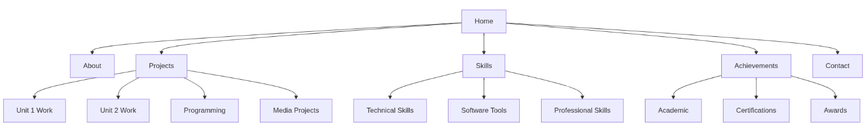

The site map also shows how each link for each page will be including the navigation link.

# 3. Page Designs

## 3.1 Home Page

**Storyboard Layout**

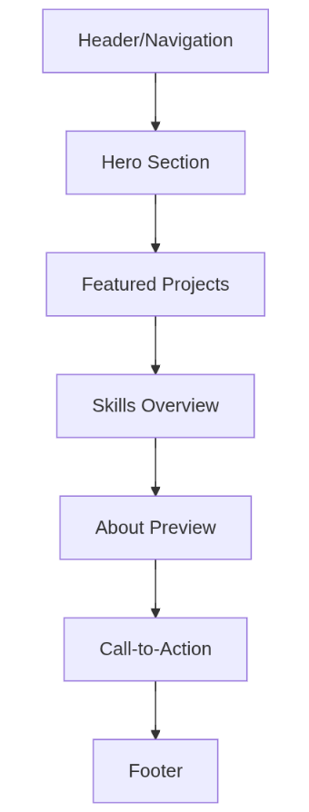

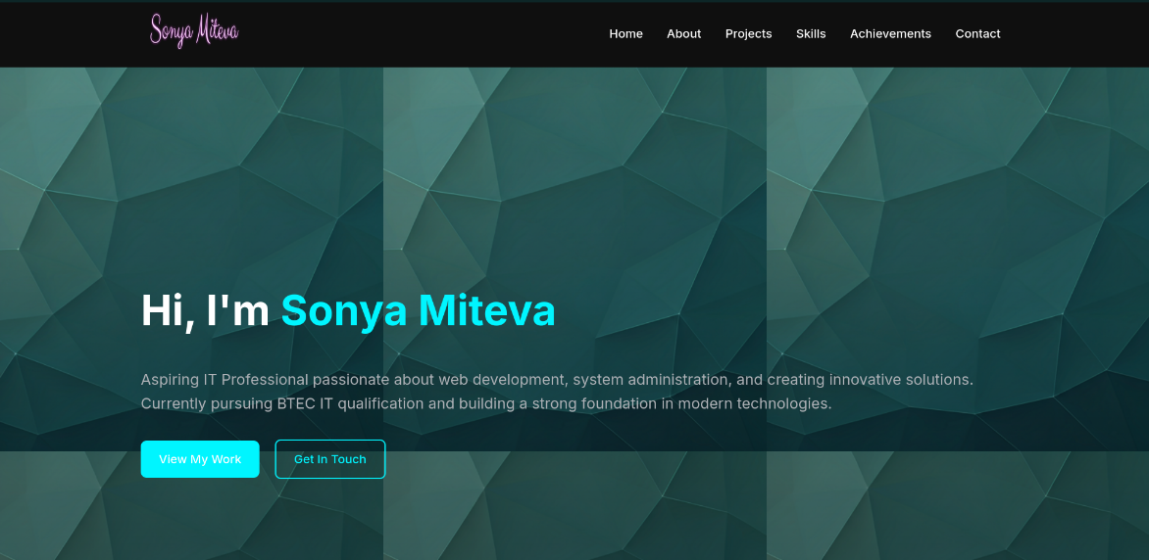

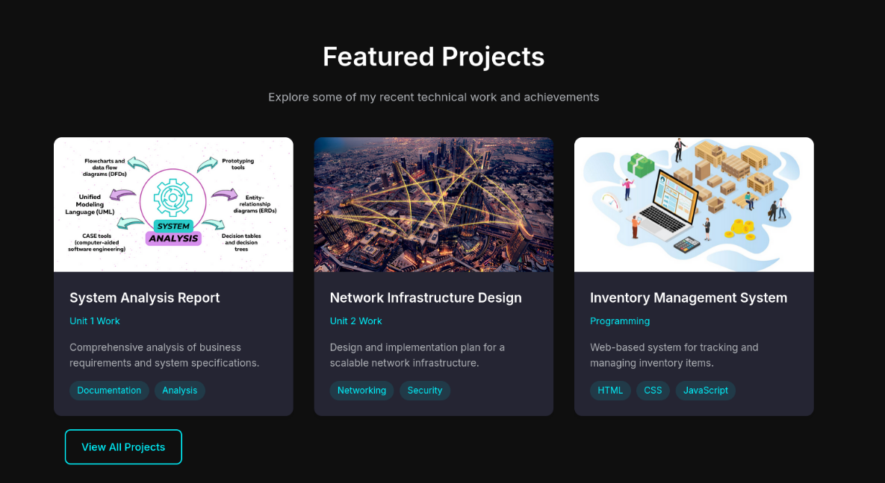

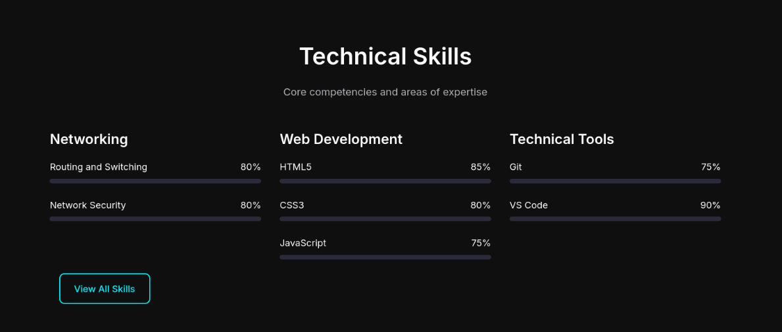

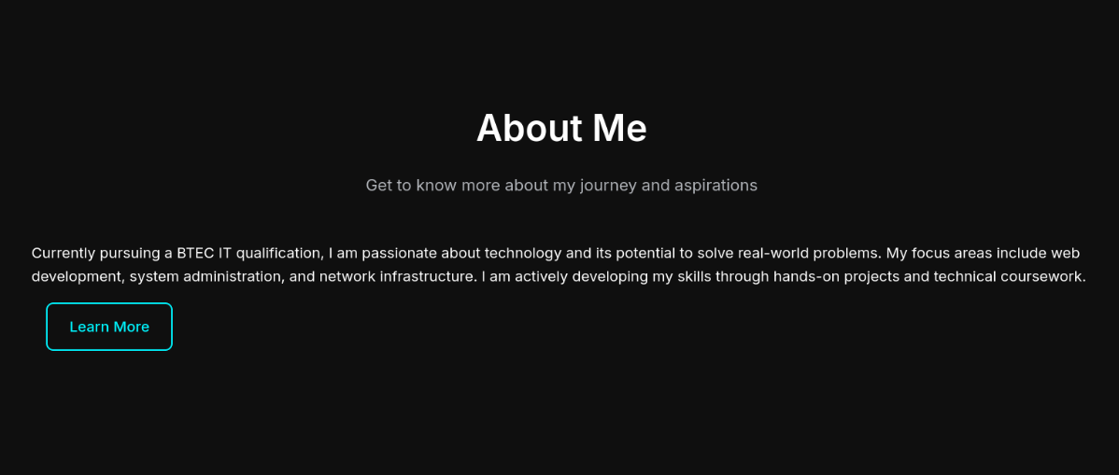

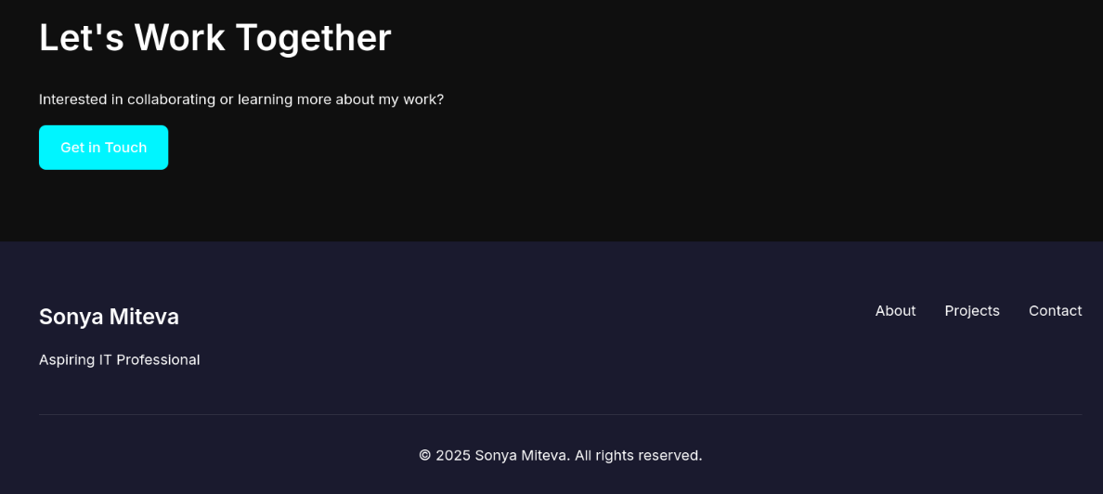

**Assets Table**

|  |  |  |  |  |  |
| --- | --- | --- | --- | --- | --- |
| **Component of page** | **Font** | **Font Size** | **Colour** | **Image** | **Source** |
|  | | | | | |
| Background Image | N/A | N/A | N/A |  | <https://lh3.googleusercontent.com/aida-public/AB6AXuCvFMGBytCRauinpx4Ik0W47acqUmWCqc0zUnujOCiJZKg78GzgxUBaStO48n9fhF7Mb7my_TkKDEP3E-OqxU5pbjc4AgZRQGxiLtBcuGXZAwEqVBeRJzwvuHfC_zMrrJ8DMf_mdaXLZUjcqtvR2apusw_WaNQLvUPaEDkN7IADJbYdM1-tsM3UJJqIbh9VmR_Z_EUSYUdmVDqenLsxlVyUwL8zVE43Yg5NY4a_5zI4EDVug2uz6VVd544U87Lbn0JKLnh7CUjr6w> |
| Page Title Font | Inter | 3.5rem | White |  | Google Font |
| Theme | Dark | N/A | N/A |  | Custom |
| Base/Body Font | Inter | 1rem | White |  | Google Font |
| Colour Palette | N/A | N/A | - Dark Navy  - Medium Navy  - Bright Cyan  - White  - Light Gray  - Black  - Dark Gray |  | Custom |
| Logo | STX | 2.5rem | -pink |  | Google Font |

## 3.2 About Page

**Layout Structure**

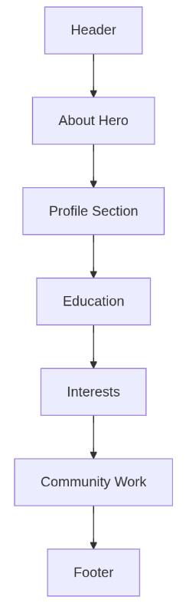

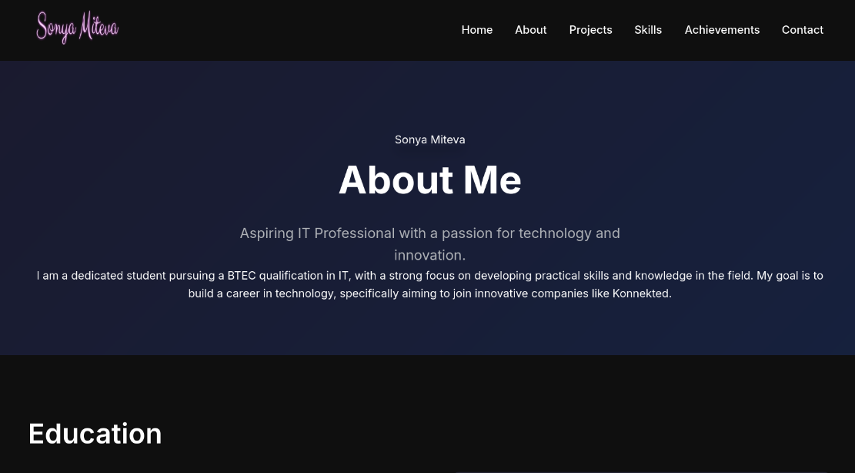



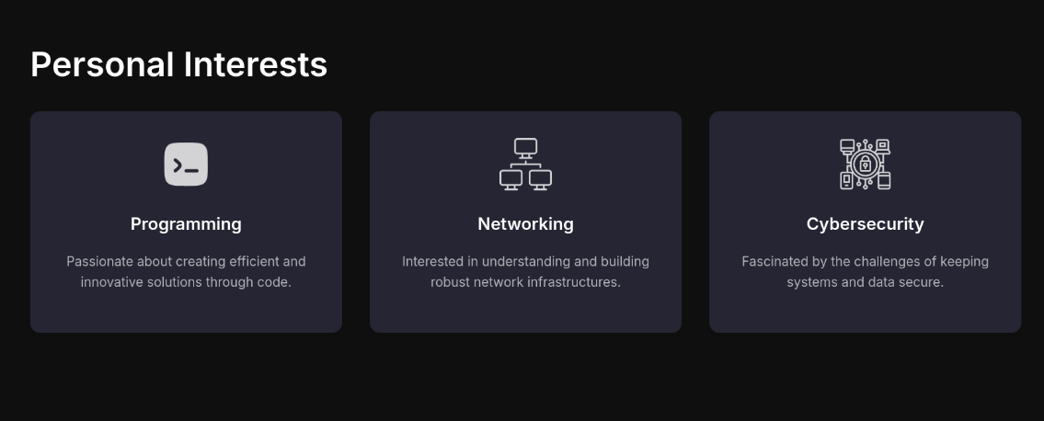

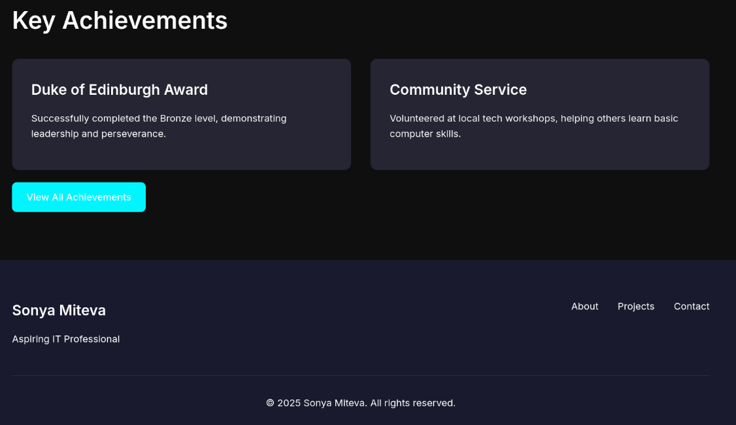

**Assets Table**

|  |  |  |  |  |  |
| --- | --- | --- | --- | --- | --- |
| **Component of page** | **Font** | **Font Size** | **Colour** | **Image** | **Source** |
|  | | | | | |
| Programming Image | N/A | N/A | N/A |  | N/A |
| Page Title Font | Inter | 3.5rem | White |  | Google Font |
| Theme | Dark | N/A | N/A |  | Custom |
| Base/Body Font | Inter | 1rem | White |  | Google Font |
| Colour Palette | N/A | N/A | - Dark Navy  - Medium Navy  - Bright Cyan  - White  - Light Gray  - Black  - Dark Gray |  | Custom |
| Cybersecurity Image | N/A | N/A | N/A |  | N/A |
| NetworkingImage | N/A | N/A | N/A |  | N/A |

## 3.3 Projects Page

**Layout Flow**

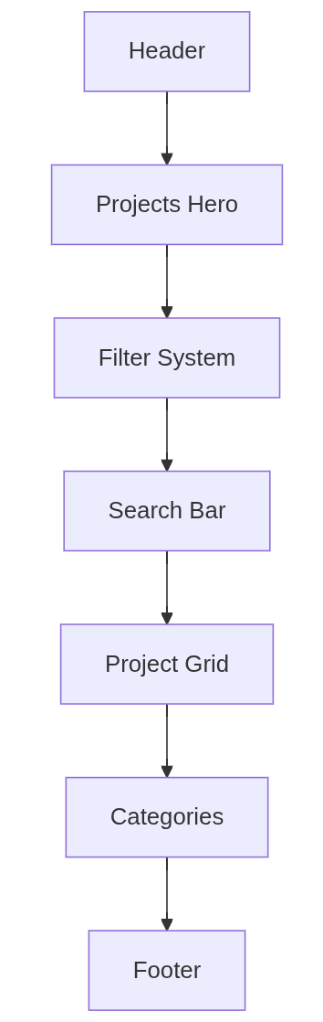

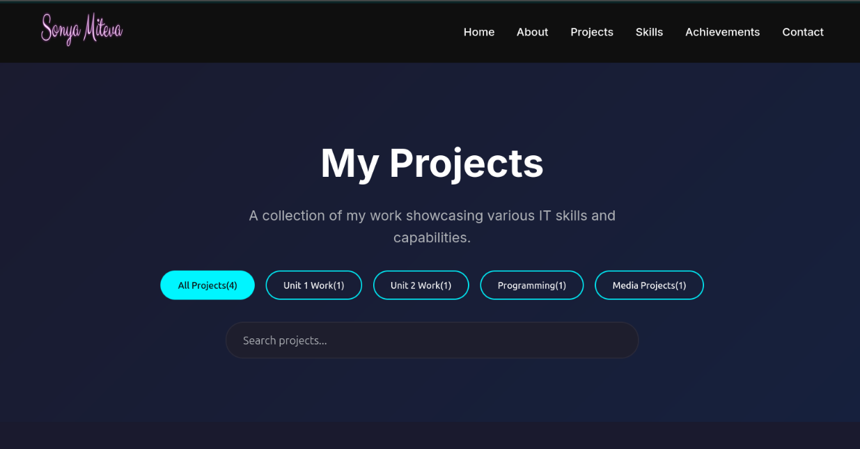

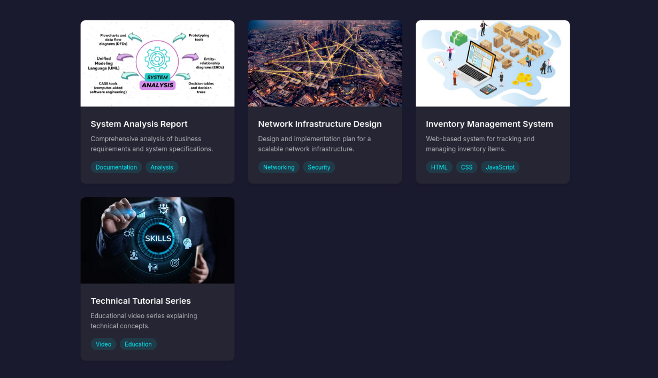

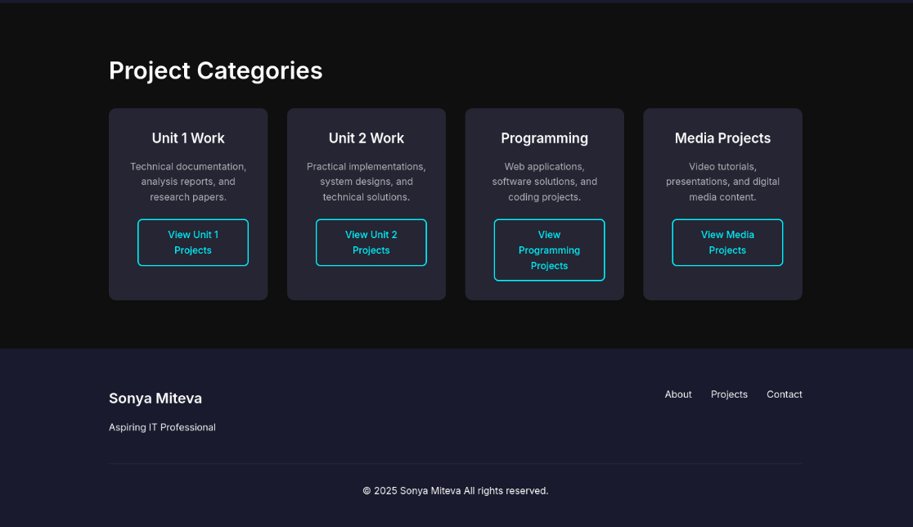

**Assets Table**

|  |  |  |  |  |  |
| --- | --- | --- | --- | --- | --- |
| **Component of page** | **Font** | **Font Size** | **Colour** | **Image** | **Source** |
|  | | | | | |
| System Analysis Image | N/A | N/A | N/A |  | N/A |
| Page Title Font | Inter | 3.5rem | White |  | Google Font |
| Theme | Dark | N/A | N/A |  | Custom |
| Base/Body Font | Inter | 1rem | White |  | Google Font |
| Colour Palette | N/A | N/A | - Dark Navy  - Medium Navy  - Bright Cyan  - White  - Light Gray  - Black  - Dark Gray |  | Custom |
| Inventory Management Image | N/A | N/A | N/A |  | N/A |
| Technical Analysis Image | N/A | N/A | N/A |  | N/A |
| Network infrastructure Image | N/A | N/A | N/A |  | N/A |

## 3.4 Skills Page

**Structure**

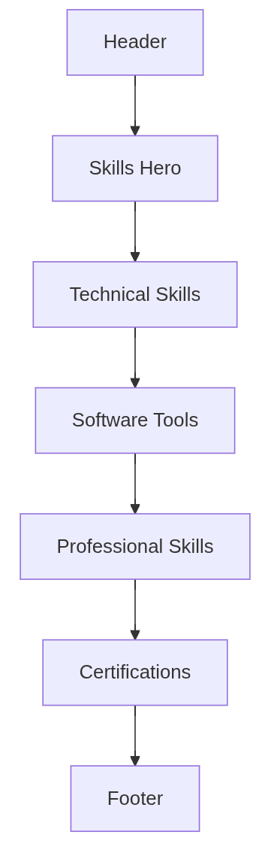

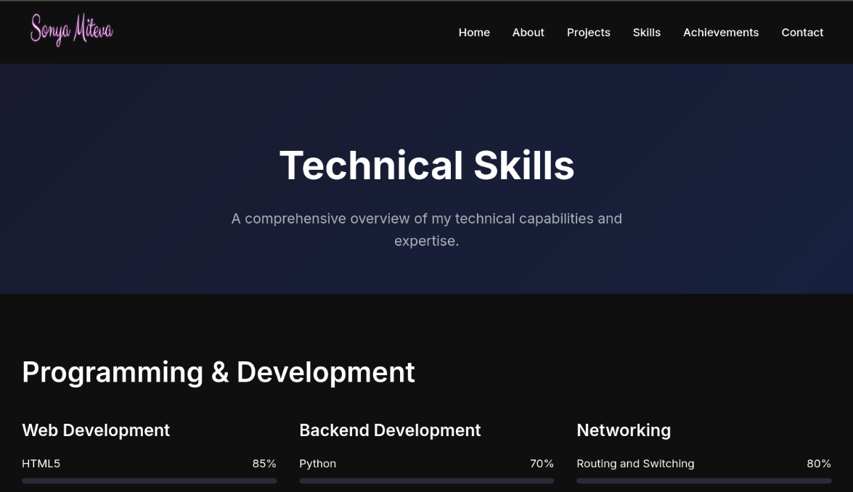

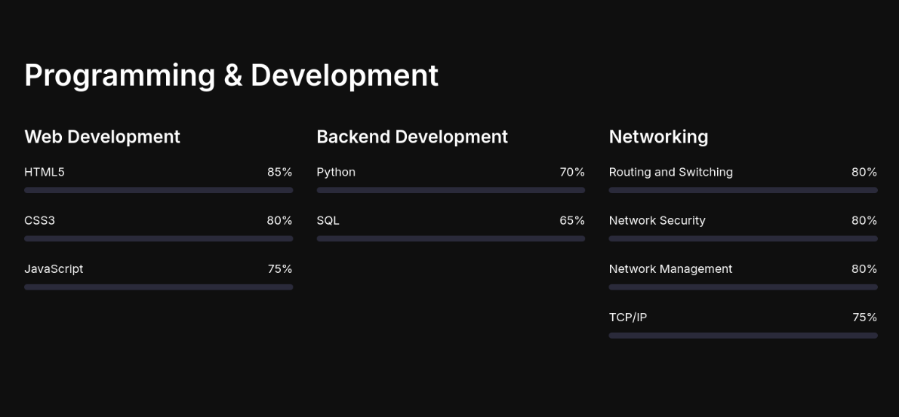

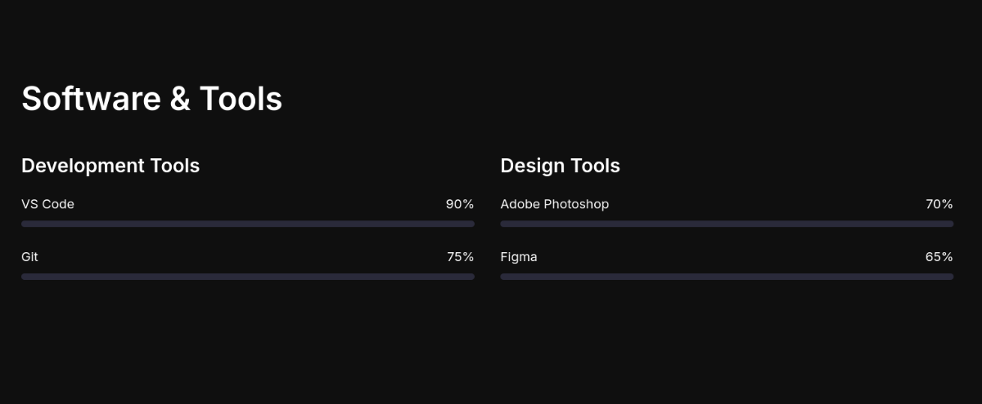

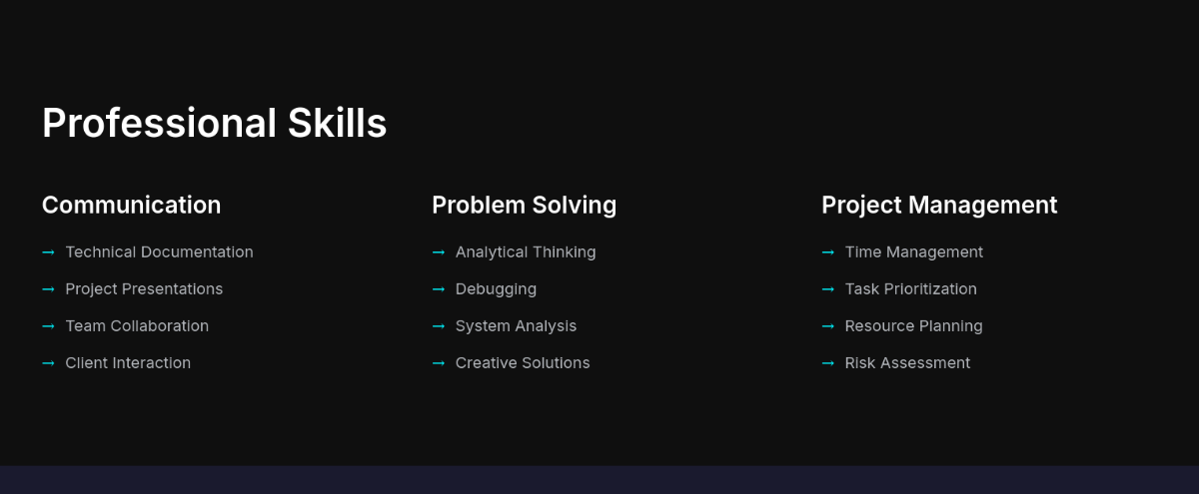

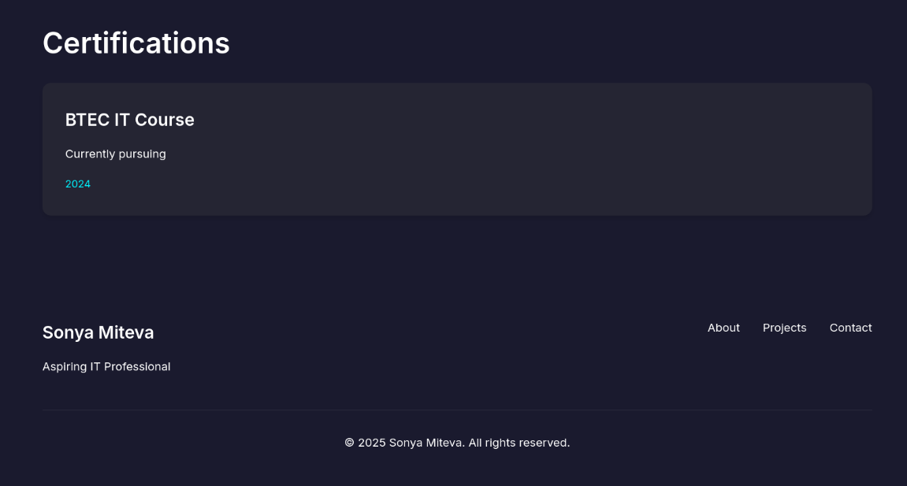

**Assets Table**

|  |  |  |  |  |  |
| --- | --- | --- | --- | --- | --- |
| Component of page | Font | Font Size | Colour | Image | Source |
|  | | | | | |
| Page Title Font | Inter | 3.5rem | White |  | Google Font |
| Theme | Dark | N/A | N/A |  | Custom |
| Base/Body Font | Inter | 1rem | White |  | Google Font |
| Colour Palette | N/A | N/A | - Dark Navy  - Medium Navy  - Bright Cyan  - White  - Light Gray  - Black  - Dark Gray |  | Custom |

## 3.5 Achievements Page

**Layout**

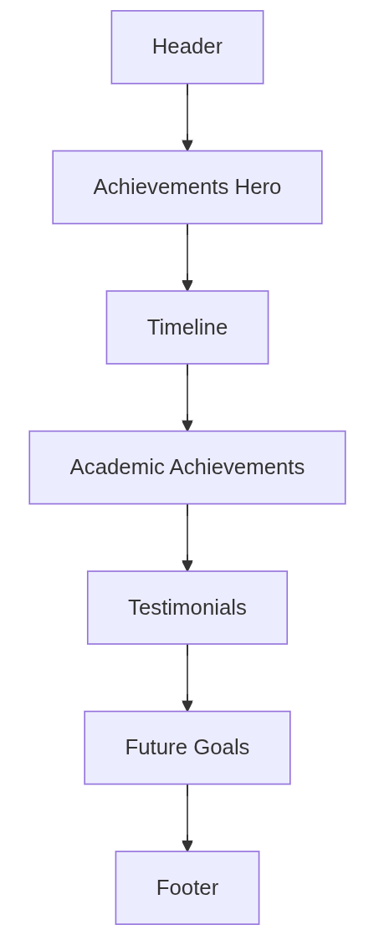

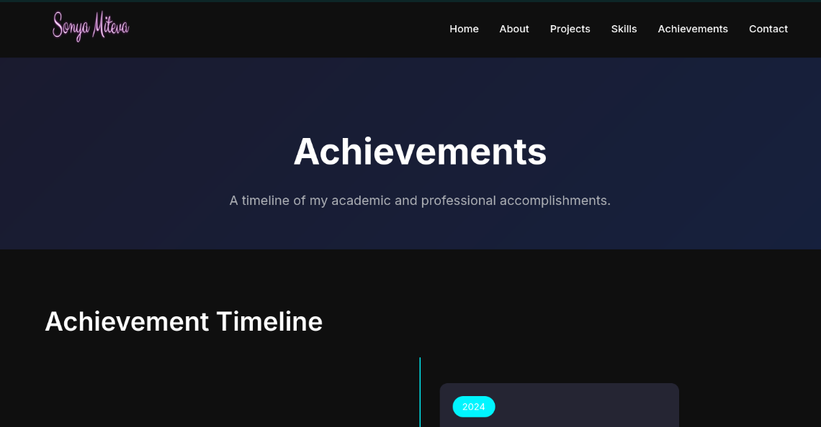

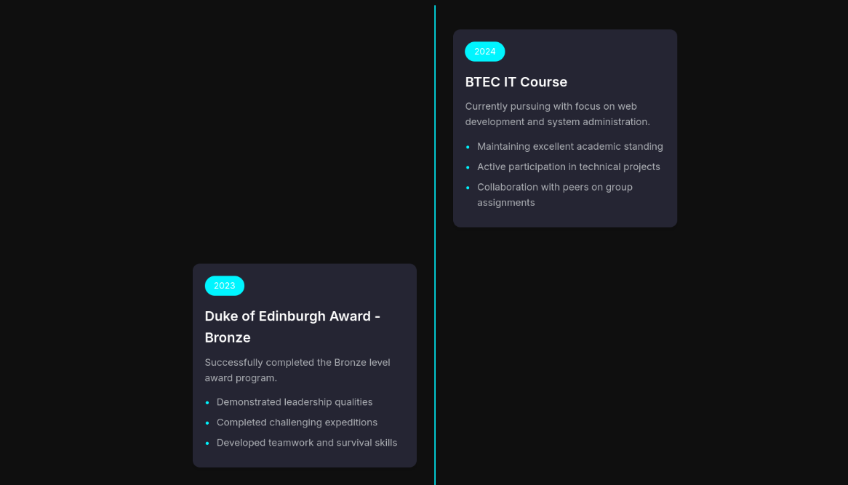

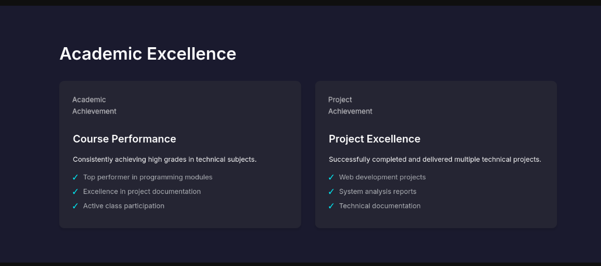

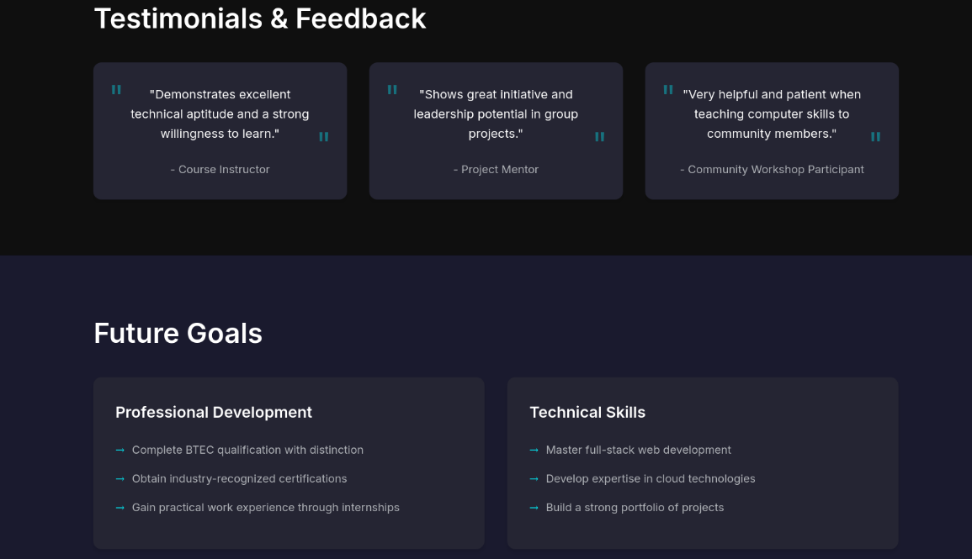

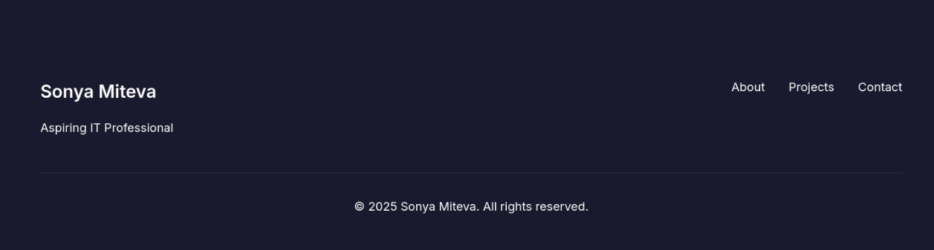

**Asset Table**

|  |  |  |  |  |  |
| --- | --- | --- | --- | --- | --- |
| Component of page | Font | Font Size | Colour | Image | Source |
|  | | | | | |
| Page Title Font | Inter | 3.5rem | White |  | Google Font |
| Theme | Dark | N/A | N/A |  | Custom |
| Base/Body Font | Inter | 1rem | White |  | Google Font |
| Colour Palette | N/A | N/A | - Dark Navy  - Medium Navy  - Bright Cyan  - White  - Light Gray  - Black  - Dark Gray |  | Custom |

## 3.6 Contact Page

**Structure**

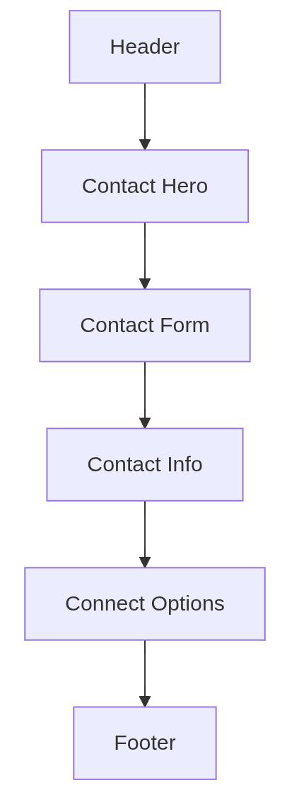

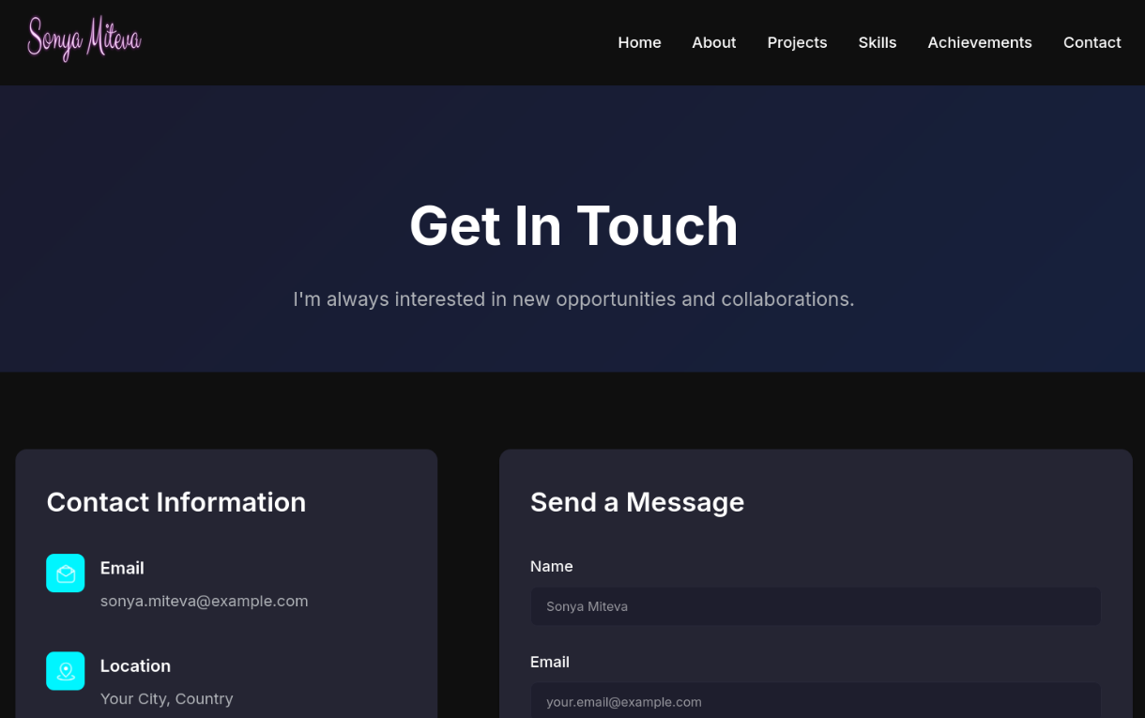

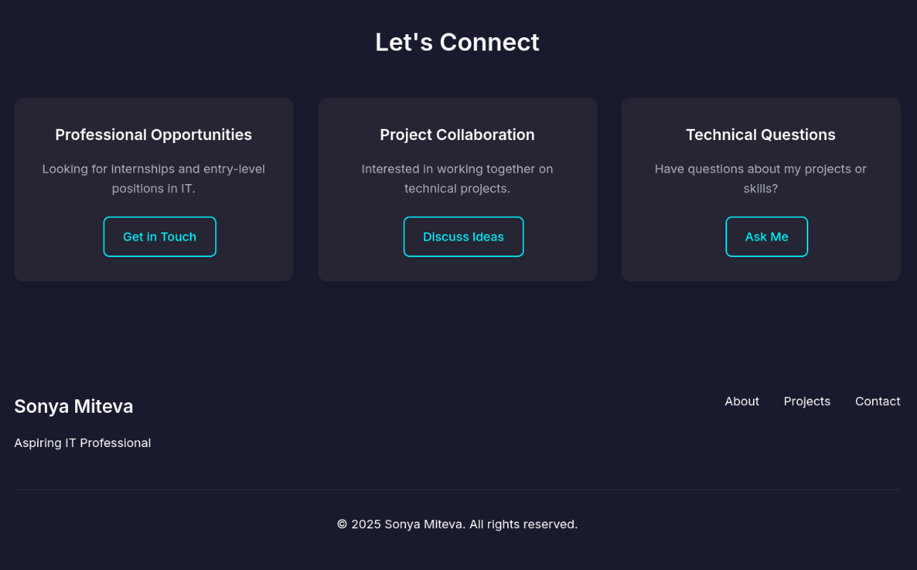

**Asset Table**

|  |  |  |  |  |  |
| --- | --- | --- | --- | --- | --- |
| **Component of page** | **Font** | **Font Size** | **Colour** | **Image** | **Source** |
|  | | | | | |
| Email Image | N/A | N/A | N/A |  | N/A |
| Page Title Font | Inter | 3.5rem | White |  | Google Font |
| Theme | Dark | N/A | N/A |  | Custom |
| Base/Body Font | Inter | 1rem | White |  | Google Font |
| Colour Palette | N/A | N/A | - Dark Navy  - Medium Navy  - Bright Cyan  - White  - Light Gray  - Black  - Dark Gray |  | Custom |
| Location Image | N/A | N/A | N/A |  | N/A |

# 4. Technical Specifications

## 4.1 Color Palette

:root {

--primary-color: #1a1a2e;

--secondary-color: #16213e;

--accent-color: #00f5ff;

--text-primary: #ffffff;

--text-secondary: #b0b3b8;

--background: #0f0f0f;

--card-bg: #252533;

}

## 4.2 Typography

--font-primary: 'Inter', sans-serif; --font-code: 'JetBrains Mono', monospace;

## 4.3 Responsive Breakpoints

Mobile: 320px - 768px

@media (max-width: 768px) { ... }

Tablet: 768px - 1024px

@media (max-width: 1024px) { ... }

Desktop: 1024px - 1200px

@media (max-width: 1200px) { ... }

Large Desktop: 1200px+

@media (min-width: 1201px) { ... }

# 5. Interactive Elements

## 5.1 Navigation

* Responsive hamburger menu
* Smooth scroll behavior
* Active state indicators
* Progress bar

## 5.2 Project Features

* Filter system
* Search functionality
* Modal windows
* Image galleries

## 5.3 Forms

* Contact form validation
* Success/error states

# 6. Alternative Design

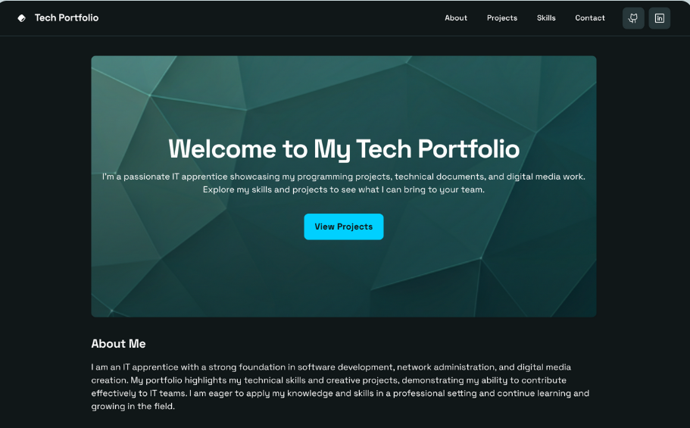

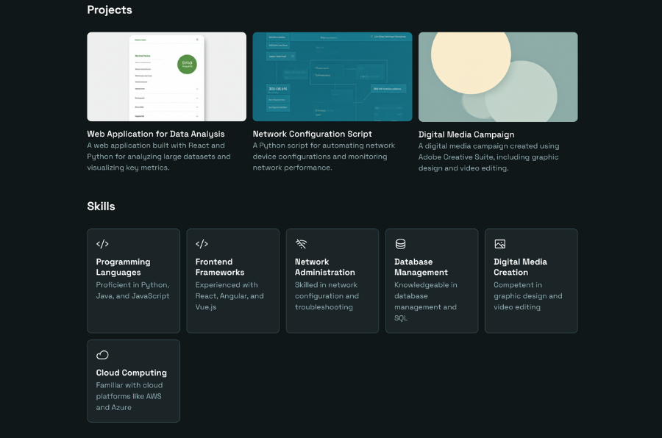

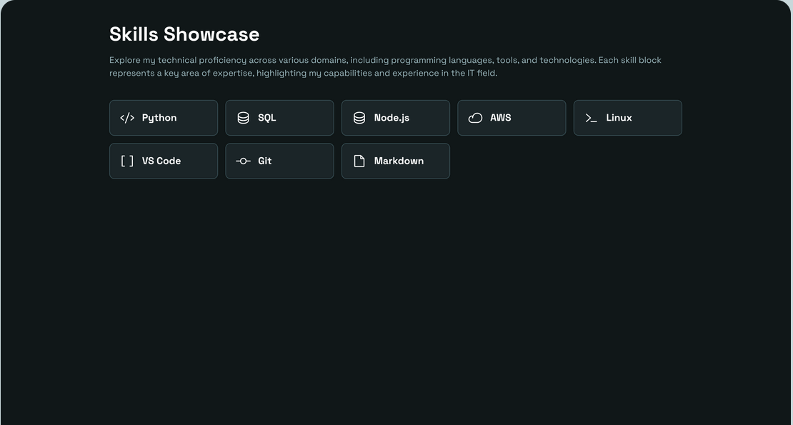

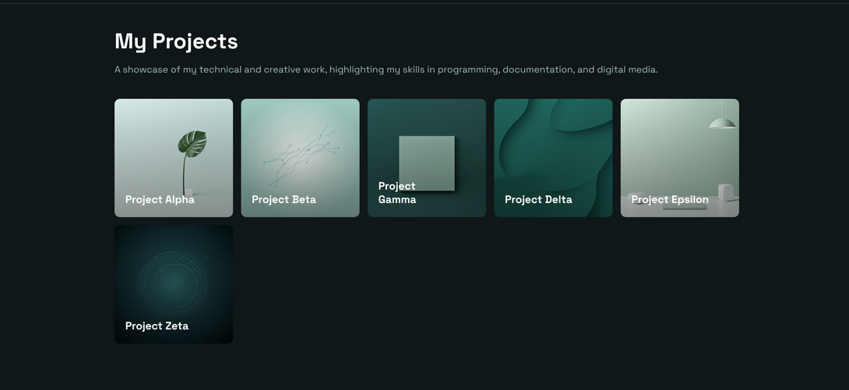

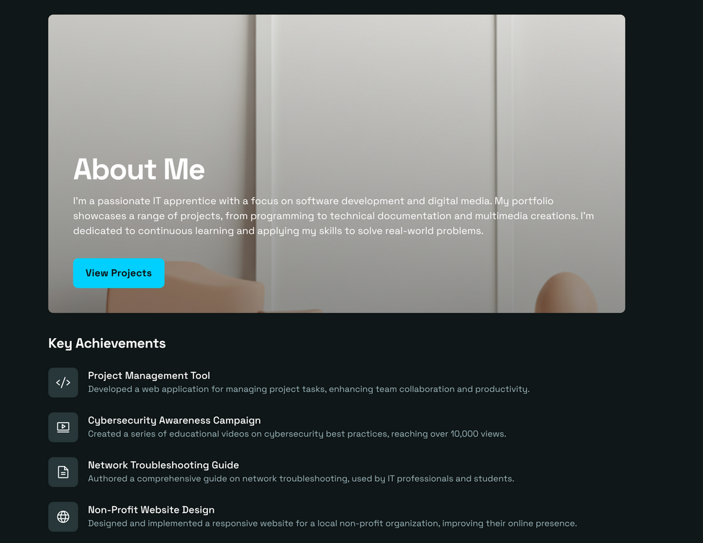

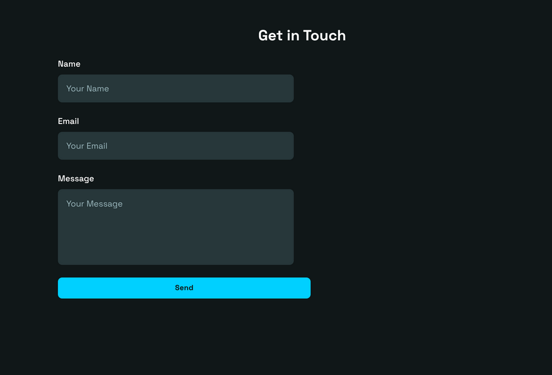

## 6.1 Reason for Alternative Design

The other design is a deliberate move to a minimalist design where the emphasis is on the clarity and simplicity of content. Contrary to the present dark-themed design featuring a dynamic look, the alternative removes the visual clutter to emphasize a minimalistic, text-driven design. It also removes animations and custom fonts, replacing them with system defaults and white space as a means of establishing structure. Navigation is reorganized into plain text links and apparent menus, removing interactivity in favor of simple usability. The presentation of the content is also dumbed down, project cards are turned into simple text lists, skill indicators are turned into simple bullets, and animations are gone. The layout is changed to a grid to single column with a tighter spacing and technical markup is minimized to basic HTML and minimal CSS, eliminating almost all animations and JavaScript requirements.

## 6.2 Justification

We still chose the existing design over this one, as it is more supportive of the portfolio goals and audience. The graphically dense interface is a better presentation of technical abilities, such as advanced CSS, JavaScript features, responsiveness, and optimization. Animations and interactive features will increase the engagement, but they also show the capability of modern web development, which is important to impress the viewers. The grid layout, card-based design enables a clean structure of diverse project content and is scalable due to its modular nature.

Moreover, the existing design strikes a good balance between accessibility and design, as it is WCAG-compliant yet provides such dynamic navigation, screen reader compatibility, as well as high-contrast typography. It is up-to-date with the industry standards and in line with the modern trends in UI/UX, making the first impression of a professional to the employer and clients. Although the alternative is light-weighted and more focused, the current design better serves the purpose of the portfolio as a technically sound and all-embracing showcase.

# 7. Testing Plan

## 7.1 Browser Testing

* Chrome (latest)

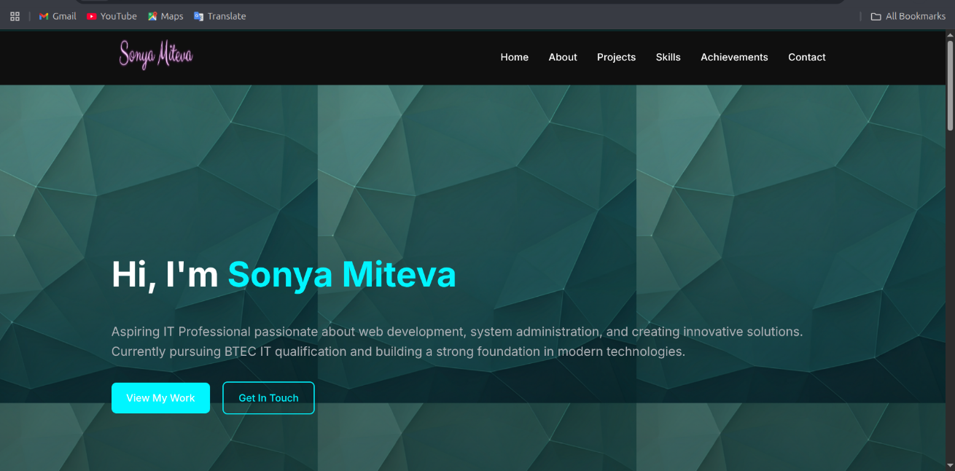

* Firefox (latest)

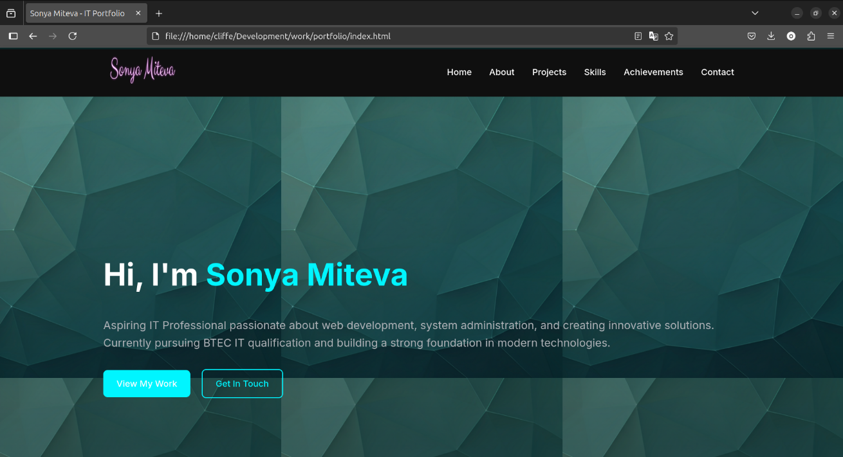

## 7.2 Device Testing

* Laptop (1366×768)

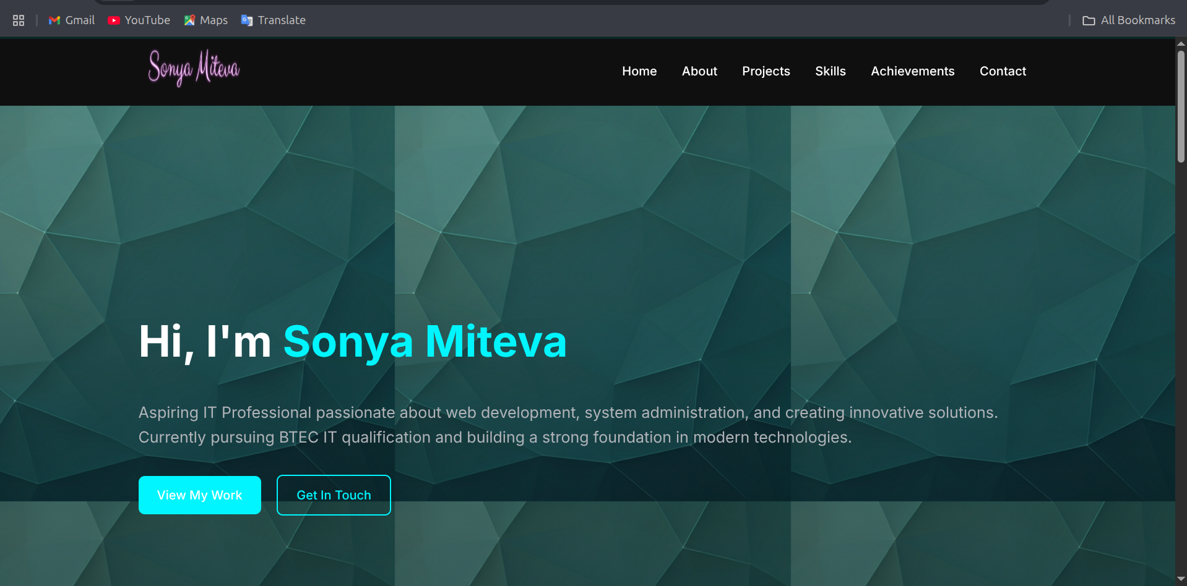

* Tablet (768×1024)

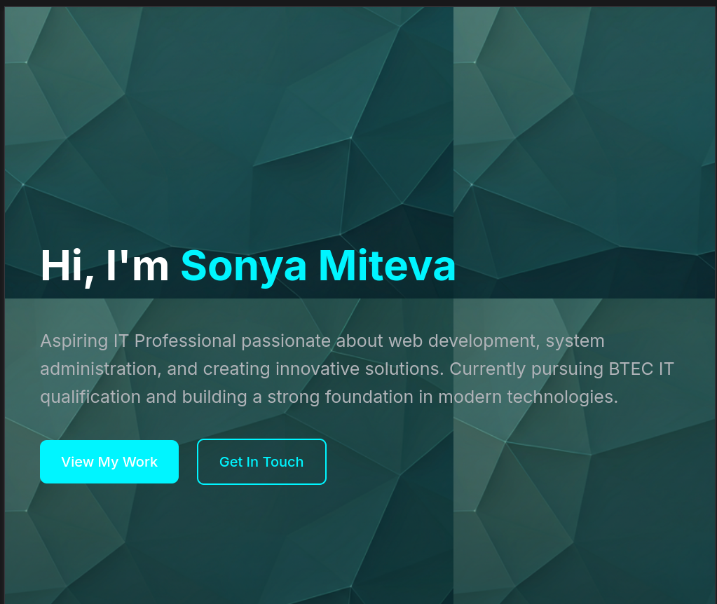

* Mobile (375×667)

